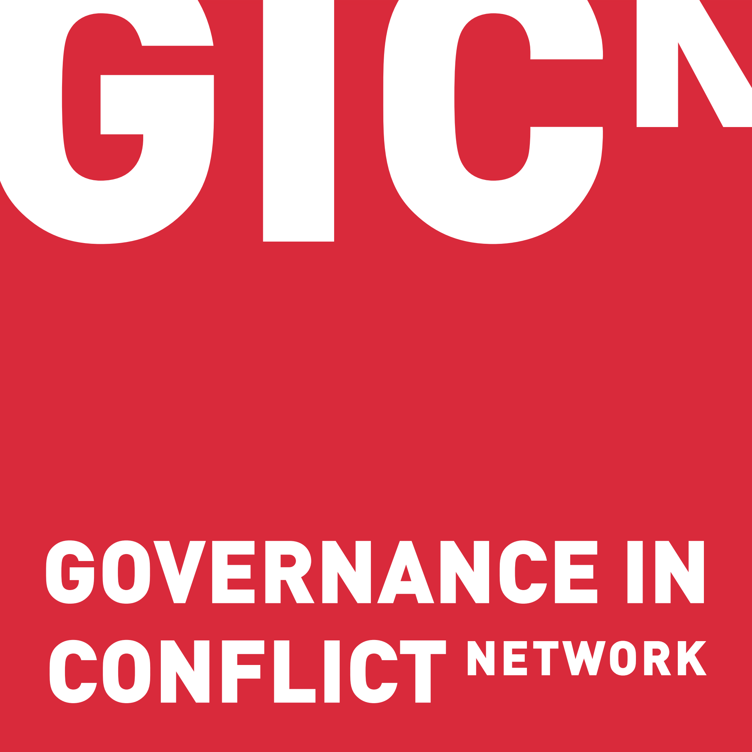
APPLICATION FORM
Short Research stays (SRS) (2020)

The application must consist of the following components:
- Annex 1 Application form
- Brief curriculum vitae (CV) of the candidate (free format, two pages at most).
- If applicable, favourable ethical recommendations or evidence of a bio-safety dossier

The application form must be filled out completely and accurately, using Arial size 11pt.

- General information

Title of the SRS
Title or brief description of the ongoing research activities
Candidate
Last name, first name
Current job title/employment
Affiliation
Current place of residence
E-mail
Date of birth
Gender
Nationality
Financer of the ongoing PhD or postdoc (if relevant)
Ghent University Promoter
Last name, first name
Department
E-mail

Targeted output of the Short Research Stay (tick as appropriate):
Research or project proposal
Scientific article or research paper

- Activities foreseen under the intended grant

  - Describe the activities proposed within this grant application in no more than 1 page (including a bibliography of articles cited). Include the following topics:

A research plan (research objectives, methods and materials, a work plan for the intended visit, possible long-term cooperation plans, bibliography, …)

Please describe the development relevance of your project proposal, PhD research and/or article proposal and how the activities fit with the goals of the Global Minds Programme (to increase the capacity of Flemish universities in knowledge, scientific approaches and technologies to sustain, improve and expand their University Development Cooperation capacity).
Description (max. 1 page)

  - Planning and feasibility

Provide a planning of your Short Research Stay.
Present the state of progress of your proposal at this moment.
- In case the targeted output is a PhD, please provide the planned date of submission and defense, and how you and your supervisor will guarantee to finish in time.
- In case the targeted output is a research proposal, an article or a research paper, please indicate where it will be submitted, and why this is an appropriate journal or conference for this particular paper or article.
Description (max. ½ page)

  - Personal motivation

Describe why it is important for you to receive this SRS scholarship and motivate how your current and future research would benefit from a research stay at Ghent University and the research group you would like to be affiliated with.

Description (max. ½ page)

To be filled in by the Ghent University promoter: Situate the proposed research activities within the department’s ongoing or planned research in the context of the Governance in Conflict network..

Description (max. 1 page)

2.5. To be filled in by the GIC partner promoter: Situate the proposed research activities within the department’s ongoing or planned research in the context of the Governance in Conflict network

Description (max. 1 page)

Abstract of the research proposal (for database use)

Give a short description of the planned research activities in up to 60 words.
Project title:

Keywords (your choice, at least 3):

Abstract of the proposed research project (max. 60 words):

The abstract of selected projects will be published on the website www.gicnetwork.be

